 



Database Programming with SQL 8-2: Count, Distinct, NVL Practice Activities

# Objectives

* Construct and execute a SQL query using the COUNT group function
* Use DISTINCT and the NVL function with group functions

# Vocabulary

Identify the vocabulary word for each definition below.

|  |  |
| --- | --- |
| **COUNT** | Returns the number of non-null values in the expression column |
| **DISTINCT** | The keyword used to return only non-duplicate values or combinations of non-duplicate values in a query. |
| **COUNT(DISTINCT)** | Returns the number of unique non-null values in the expression column. |

# Try It / Solve It

1. How many songs are listed in the DJs on Demand D_SONGS table?

SELECT COUNT(DISTINCT title)

FROM d_songs;

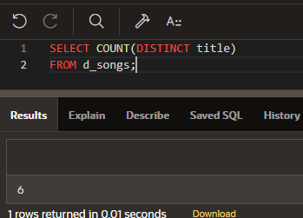

1. In how many different location types has DJs on Demand had venues?

**SELECT COUNT(DISTINCT  loc_type)**

**FROM d_venues;**

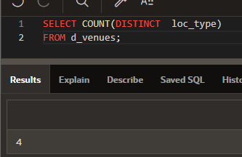

1. The d_track_listings table in the DJs on Demand database has a song_id column and a cd_number column. How many song IDs are in the table and how many different CD numbers are in the table?

SELECT COUNT(song_id) AS "song with possible duplication", COUNT(distinct cd_number) "cd no. distinct"

FROM d_track_listings;

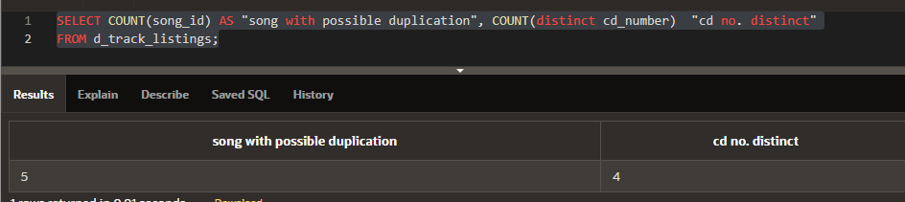

1. How many of the DJs on Demand customers have email addresses?

SELECT COUNT(email) "count with email"

FROM d_clients;

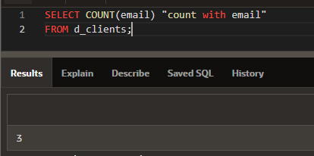

1. Some of the partners in DJs on Demand do not have authorized expense amounts (auth_expense_amt). How many partners do have this privilege?

SELECT (COUNT(*) - COUNT(auth_expense_amt)) "Free from limit count"

FROM d_partners;

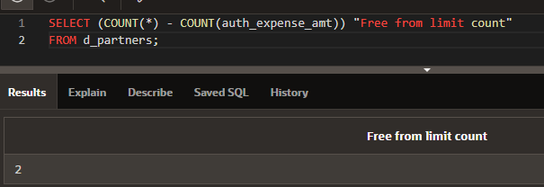

1. What values will be returned when the statement below is issued?

|  |  |  |
| --- | --- | --- |
| **ID** | **type** | **shoe_color** |
| 456 | oxford | brown |
| 463 | sandal | tan |
| 262 | heel | black |
| 433 | slipper | tan |

SELECT COUNT(shoe_color), COUNT(DISTINCT shoe_color) FROM shoes;

Shoe_color = 4, shoe_color = 2

1. Create a query that will convert any null values in the auth_expense_amt column on the DJs on Demand D_PARTNERS table to 100000 and find the average of the values in this column. Round the result to two decimal places.

SELECT TO_CHAR(ROUND(AVG(NVL(auth_expense_amt,100000)),2), '$999999.99')

FROM d_partners;

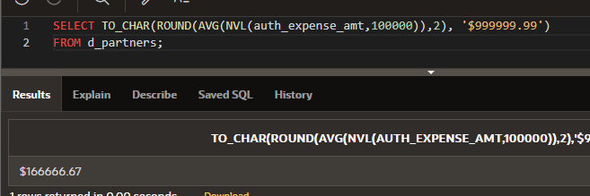

1. Which statement(s) is/are True about the following SQL statement: SELECT AVG(NVL(selling_bonus, 0.10))

FROM bonuses;

a. The datatypes of the values in the NVL clause can be any datatype except date data. ЛОЖЬ selling_bonus должен быть того же типа что 0.10, а AVG принимает только числовые

b. If the selling_bonus column has a null value, 0.10 will be substituted. ВЕРНО

c. There will be no null values in the selling_bonus column when the average is calculated. ВЕРНО

d. This statement will cause an error. There cannot be two functions in the SELECT statement. НЕВЕРНО, AVG групповая а внутри NVL нет

1. Which of the following statements is/are TRUE about the following query? SELECT DISTINCT colors, sizes

FROM items;

a. Each color will appear only once in the result set. ЛОЖЬ

b. Each size will appear only once in the result set. ЛОЖЬ

c. Unique combinations of color and size will appear only once in the result set. ПРАВДА

d. Each color and size combination will appear more than once in the result set. ЛОЖЬ

Copyright © 2020, Oracle and/or its affiliates. All rights reserved. Oracle and Java are registered trademarks of Oracle and/or its affiliates. Other names may be trademarks of their respective owners.